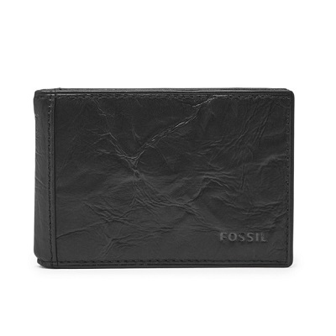

NEEL MONEY CLIP BIFOLD

PRODUCT DETAILS

**Silhouette: Bifold**

**Exterior Material: Leather**

**Interior Details: 6 Credit Card Slots, 1 ID Window and 1 Money Clip Holder**

**Measurements: 4"L x 0.50"W x 2.75"H**

**Warranty: 1 Year Limited**